TOWNSHIP OF WINFIELD
BUILDING DEPARTMENT

SWIMMING POOL REQUIREMENTS

*************************************************************************************

All swimming pool installations are required to comply with the requirements of the 2015 International Swimming Pool and Spa Code.

All pools will also require a prior approval from the Winfield Mutual Housing Corporation.

Submit completed applications for the work intended, and 2 copies of plans and all specs including, but not limited to, pumps, filters, heaters, drains, lights, gas riser diagram, fence and latch, etc.
The completed construction permit application shall include: Construction Permit Application Folder
Building Subcode Technical Section (Pool, spa & fence) Electrical Subcode Technical Section
Plumbing Subcode Technical Section (Gas piping, pool heater & pool drains) Fire Subcode Technical Section*
Application for Certificate
Copy of all contractors licenses and/or registrations
2 copies of property survey (show pool, spa, fence, etc.)
2 copies of:

□ | Signed/Sealed pool plan | □ Manufacturer Instructions (above ground)
□ | Pumps | □ Ladder w/ Built in Gate (above ground pool)
□ | Filter | □ | Lights
□ | Heater | □ | Pool Drains
□ | Fence | □ | Latch
□ Gas Riser diagram (if installing pool heater)

Upon completion of the pool installation, a final topographical survey must be submitted to the building department for the issuance of a certificate of occupancy. Pools cannot be utilized until a certificate of occupancy is issued.

Electrical Requirements:

Ø
Direct burial cable is not permitted for pool pump wiring. Metal or PVC conduit system is required outside the dwelling unit. A wet location wire with insulated green ground is required. Interior may be any wiring method recognized in Chapter 3 of the 2015 National Electrical Code.
- Minimum filter motor attachment cord size #12 AWG (max 3 feet in length)

Minimum wire size #12 AWG. A 20 ampere locking type outlet is required for filter motor connection for above ground pools. This receptacle shall be located not closer than 6 feet from the pool wall. It shall be ground fault protected and shall employ an In-Use cover. This circuit shall be dedicated to the filter motor.

A convenience outlet shall be located not less than 6 feet and not more than 20 feet from the inside wall of the pool. It shall be ground fault protected and shall be connected to a general purpose branch circuit in the dwelling. In-Use cover is required.

All metal parts within 5 feet of the pool shall be bonded together with a #8 solid copper wire and shall be bonded to the filter motor. i.e. fences, bilco doors, etc.

Burial depth is routinely 18 inches for conduit (6 inches for rigid galvanized metal conduit)

A #8 solid copper wire is required to be installed between the pool chassis and a lug
provided on the filter motor. A proper lug, nut, bolt and lock washer is required on the pool chassis. (stainless or brass) An equipotential bonding grid must be formed around the pool with a minimum #8 sold copper wire and connected to the pool pump in at least 4 points equally spaced around a metal pool frame.

The filter pump may be hard wired but a disconnecting means is required. A timer is required for the filter pump motor.

Pool water must be bonded electrically (call for more information) A minimum 9 square inch in direct contact with the water.

For pools, spas and hot tubs, refer to the 2014 National Electrical Code, Article 680 (Other codes may apply)
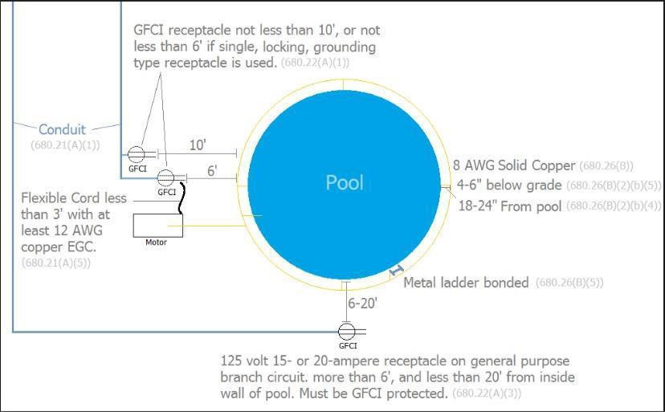

Pool Fence Requirements

Private swimming pools must be surrounded by a barrier, such as a fence or wall. The barrier must meet the following requirements.

Ø
The top of the barrier shall be at least 48 inches above finished ground level measured on the side of the barrier, which faces away from the swimming pool. The maximum vertical clearance between finished ground level and the bottom of the barrier shall be 2 inches measured on the side of the barrier, which faces away from the swimming pool.
Ø
Solid barriers shall not contain indentations or protrusions except for normal construction tolerances and tooled masonry joints.
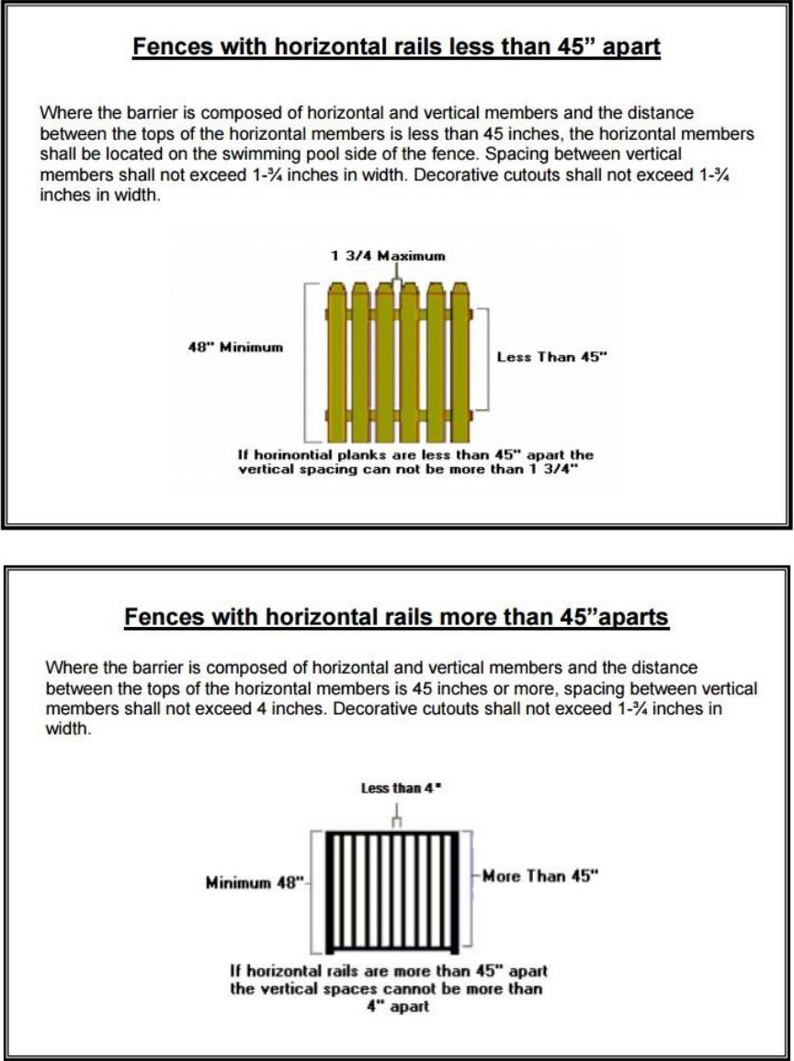

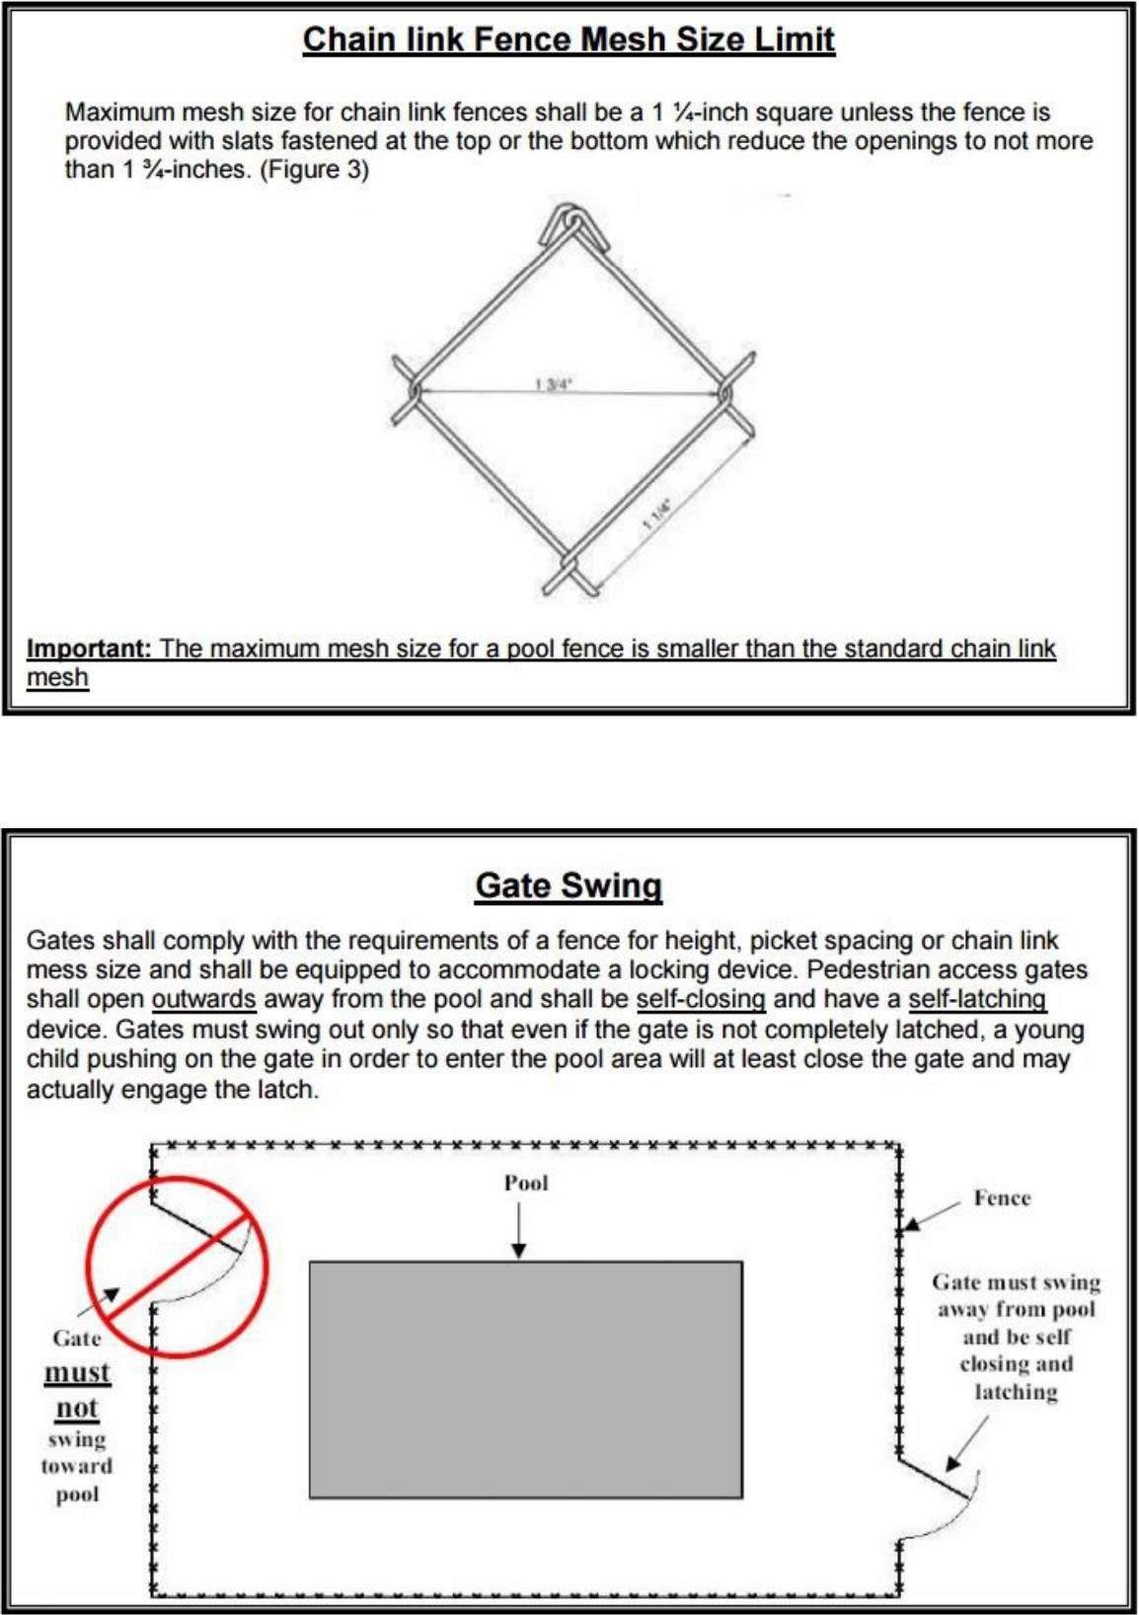

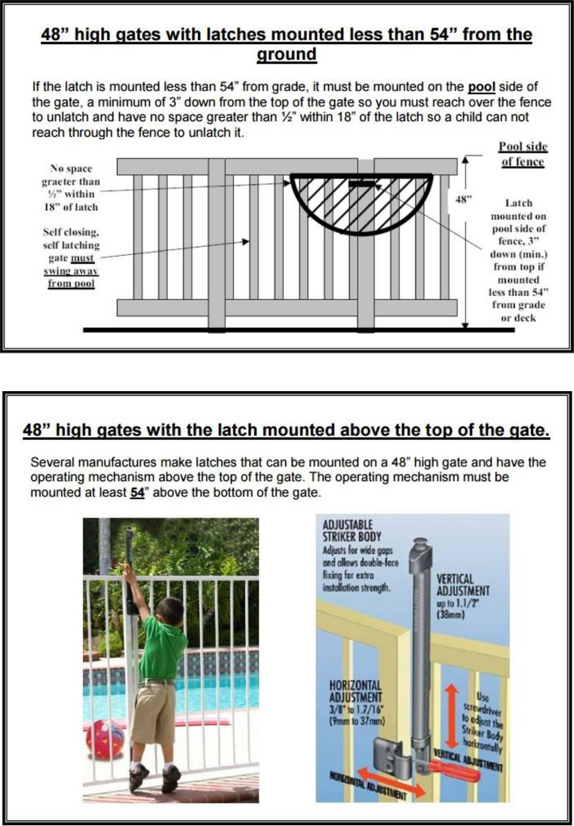

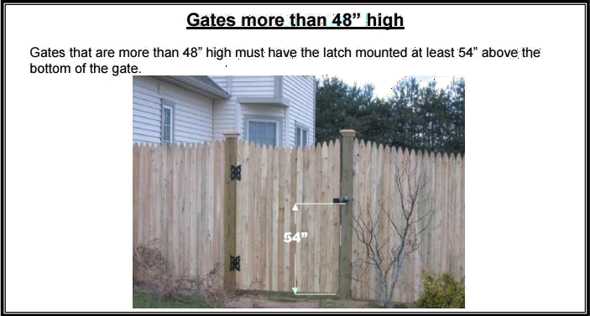

Above ground pools

Barriers are required for above ground pools, a removable ladder is not an acceptable barrier for an above ground pool. The barrier may be a compliant fence that surrounds the entire pool or yard. Zoning requires a compliant fence around the pool or around the property.
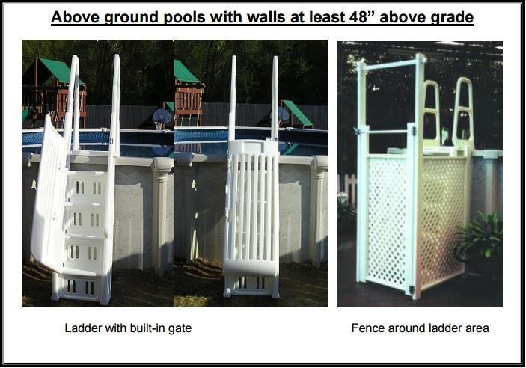

Above ground pools on sloped site

Where the walls of an above-ground pool are used as the barrier, are on a sloped site, which will make a portion of the top of the pool structure to be less than 48” to grade, a minimum of 3-foot level surface around the portion of the pool structure that is less than 48” to grade should be provided. The level surface should be measured away from the pool wall to the excavation edge and should be tapered away from the pool at a minimum of 45-degree angle for a distance of one half the level surface.
